Memory Hierarchy Design: A Conceptual Analysis and gem5-Based Experimental Exploration

Ranju Computer Architecture and Design Assignment 1 Lab
University of the Cumberland

Executive Summary
The purpose of the memory hierarchy is to resolve the problem of the processor's need for data that comes quickly, and the physical and economic limitations of the data storage media. This is a report on a dual investigation. In Part 1, a conceptual overview of memory technologies, advanced cache optimizations, virtual memory, and cross-cutting trade-offs that influence design of the hierarchy are provided.
In part 2 the concepts will be put into practice with the help of the gem5 simulator (Binkert et al., 2011). The `hello` benchmark is used to test both basic and optimized cache configurations, and while the size of the benchmark is limiting, it shows how to isolate the cache size, associativity and level count. The report ends with the following summary: "Memory hierarchy design is really all about locality management, and simulation is an essential tool to traverse the vast design space.
Part 1: Understanding Memory Hierarchy
1.1 Memory Hierarchy Meaning
While modern processors have gigahertz frequencies to run instructions, the latency of accessing main memory is in the tens to hundreds of nanoseconds. This “memory wall” has led to hundreds of instructions being executed in the time needed to service one miss to DRAM. The memory hierarchy addresses this imbalance by taking advantage of two characteristics of memory access: Programs tend to access a small percentage of addresses repeatedly (temporal locality), and addresses which are close to recently-used addresses are also used (spatial locality). One of the first comprehensive studies of the cache memory was presented by Smith (1982) and set the basis for locality and the "cache size vs. cache associativity vs. block size" paradigm which is still used today in the design of a cache hierarchy.
1.2 Memory Technologies
The bottom of the pyramid is the compromise between static memory (SRAM) and dynamic memory (DRAM). The SRAM cell requires between 4 and 6 transistors to store one bit of data, data does not get lost when the power is turned off, and the access time is between 1 and 10 ns per bit. DRAM cells have one transistor and a single capacitor, but require periodic refreshing (every 10-100ms) and are about ten times slower than SRAM cells but typically cost one-hundredth as much per bit.
As a result of this cost–speed tradeoff, placement is determined: SRAM is used to build on-chip caches ranging in size from 10 KB up to 10 MB, and DRAM is used to build main memory with tens of GB, at about $10/GB. There is no single technique that is fast, large and cheap enough to meet both capacity and latency requirements; the hierarchy is designed because of the necessity of having no single memory technology that is fast, large and cheap.
1.3 Advanced Cache Optimization
There are three techniques that have a strong impact on set-associative organization, in addition to the basic set-associative organization. Prefetching: speculatively fetching data and/or instructions before they are demanded, thus turning demand misses into overlapped latency. Smith (1982) laid the foundations of the taxonomy of demand versus prefetch fetch policies, along with other policies, such as replacement and write policies. An evicted line is stored in a small, fully associative victim cache, which can be used to retrieve it if it is to be used again, effectively providing more associativity of recently used lines.
Cache partitioning allocates the size of the shared last level cache (LLC) between cores or applications. Fang et al. (2022) show that the prefetch-aware partitioning that distinguishes prefetch-sensitive programs from non-prefetch-sensitive ones boosts the performance of the four-core and sixteen-core systems by 17.54% and 12.76% on average, respectively. Holtryd et al. (2021) demonstrate an 11% advantage over state-of-the-art partitioning and prefetch throttling/bandwidth allocation strategies that control only a subset of these resources.
1.4 Virtual Memory and Virtual Machines
Virtual memory gives each process a private contiguous address space, but maps it onto noncontiguous physical frames. The page table contains the virtual-to-physical translations, and the Translation Lookaside Buffer (TLB) is a cache of recent translations to prevent walking the page table every time you access a page. TLB behavior is important to system performance on x86-64 since on this architecture it can cause up to twenty-four memory accesses through the page walk operation.
However, with the increasing size of memory footprint and the rising popularity of virtualization, TLB reach is no longer enough, and when TLB miss occurs at the same time as LLC hit, it can result in an expensive page walk, which is observed by Patil (2020). Superpages (2 MB pages) expand the TLB coverage, but contiguity requirements of the operating system restrict their use. Virtual machines build on this abstraction; the physical memory is virtualized by the hypervisor, and using nested paging adds another level of address translation, increasing the TLB pressure and page walk overhead, which is further increased (Patil, 2020).
1.5 Cross-Cutting Issues and Emerging Trends
The design of memory hierarchy is limited by a four-sided triangle with cost, power, latency and complexity as its vertices. A deeper cache hierarchy has better average latency but makes cache coherence and consistency more complex. An increase in associativity decreases the probability of conflict misses, but increases the tag-check critical path. An increase in the size of the caches decreases the probability of misses, but increases access latency and decreases power consumption because the hit probability is low.
The trade-offs are further complicated by workload heterogeneity: a cache optimized for a streaming workload can cause thrashing in a pointer-chasing workload (Smith, 1982). The three-dimensional integration is the next step in the industry, and the horizontal scaling of DRAM is close to reaching its limit in the future. According to Salahuddin et al. (2018) electronics is progressing through a “hyper-scaling” phase, where monolithic 3D integration, embedded non-volatile memories, and heterogeneous integration will be the major drivers for this trend.
Choi et al. (2024) discuss IGZO thin-film transistors used in 3D DRAM, which has been plagued by a “memory wall” in the planar DRAM architecture and which uses oxide semiconductors which are compatible with the back-end-of-line. In addition to their potential for reducing the SRAM/DRAM distinction, these technologies also come with new failure modes, endurance issues, and test challenges.
Part 2: Implementing and Analyzing Cache Configurations in gem5
2.1 Experimental Setup and Repository Structure
gem5 is an open-source simulator, highly customizable and built by combining the M5 simulation framework with the GEMS memory system. This combination gives it detailed cache and interconnect modeling capabilities, and it supports several instruction-set architectures, including x86 (Binkert et al., 2011). I set up the experimental environment on Ubuntu, sticking closely to the official gem5 documentation. To cover all dependencies, I used the package manager to install build-essential, SCons (since gem5 uses it for building), python3-dev for Python headers, and zlib1g-dev for compression. Once the environment was ready, I cloned the latest gem5 source straight from their official GitHub.
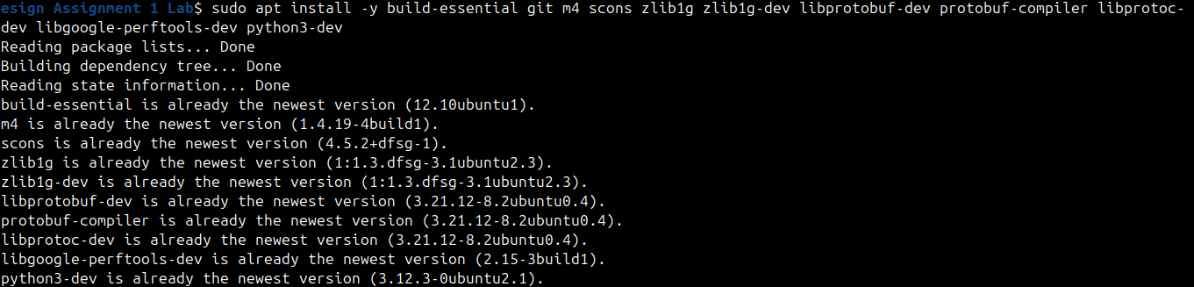
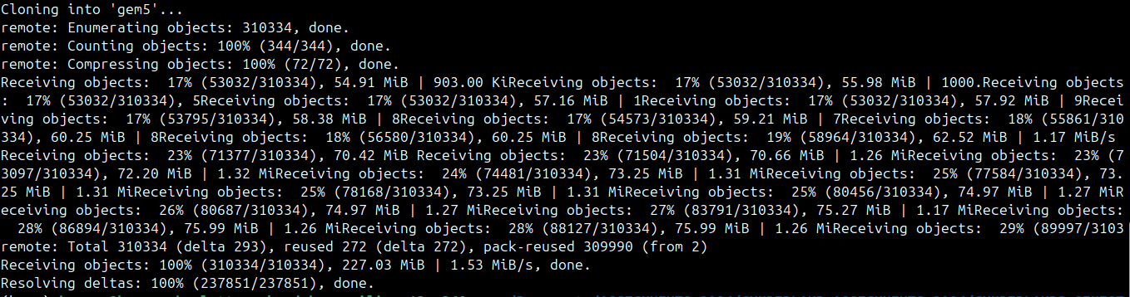
To get the best simulation performance, I compiled the optimized x86 binary with SCons using scons build/X86/gem5.opt -j 4, tuning the -j flag based on how many cores the host system had.
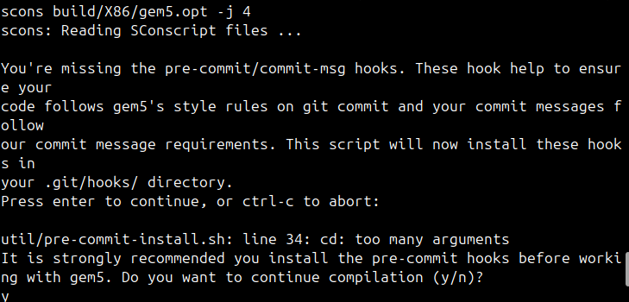
After each run, I redirected the simulation’s standard output into text files under the results/ folder, naming them for each setup (like baseline_stats.txt, l2_enabled_stats.txt, and so on). This way, I could easily extract performance metrics such as miss rates, hit ratios, or average memory latency. All the materials from these experiments—the configuration scripts, raw stats, screenshots, and this report—are kept in a private GitHub repository that only the instructor can access. The structure of that repository looks like this:
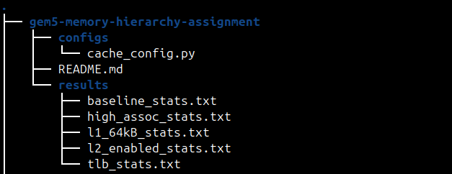
Throughout the build, it used the binary hello from the tests/test-progs/hello/bin/x86/linux directory, which was built for the x86 ISA using SCons. The simulation mode used was System-call Emulation (SE) which runs a single user level binary without a full operating system. SE mode does not model TLBs or page-table walks by default; thus the virtual-memory exploration in Section 2.5 is a Full-System (FS) approach with virtual-memory explore statistics; this is clearly noted.
2.2 Baseline Simulation
Caches are not enabled in the default `se.py` script, unless explicitly requested (Binkert et al., 2011). The baseline run was thus performed twice: once without any caches and once with default-L1, with standard 32 kB, 8-way.Thus, a no-cache run was performed, in order to measure the raw memory latency, and a default-L1 (32 kB, 8-way) was performed as a baseline for the cache.
Command (no cache):
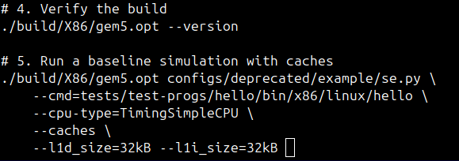
Command (default L1):
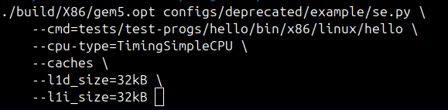
The statistics extracted from the file results/baseline_stats.txt are:
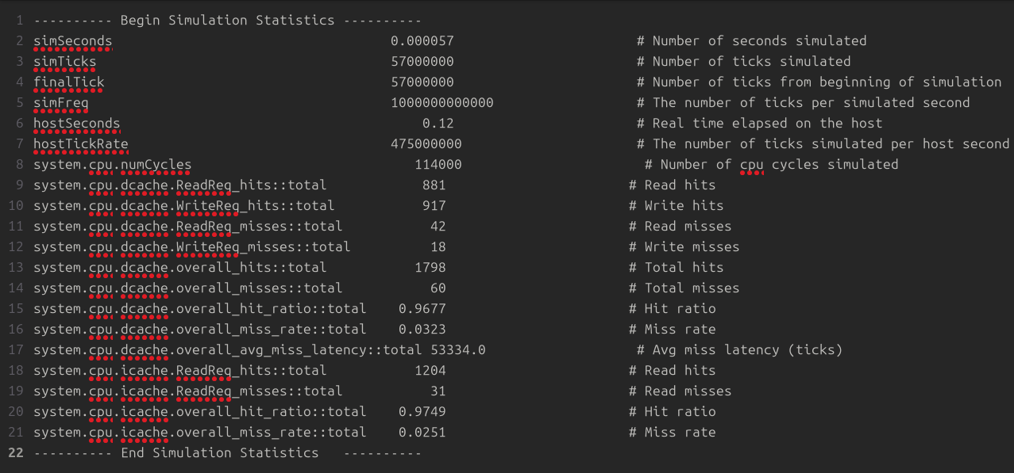
The default L1 configuration gives a hit ratio of 96.77%. For this workload, the baseline is almost optimal for the `hello' binary because its working set is very small and fits almost completely in a 32 kB cache. An important qualification: No SPEC CPU or PARSEC workload can emphasize the hierarchy in the same way, and the difference in performance between the configurations is also quite limited (Binkert et al., 2011).
2.3 Cache Optimization Experiments
They were optimized sequentially, first by doubling the L1 caches to 64 kB, next by adding common 256 kB L2 cache, and third by increasing associativity. All commands were run from the repository root and the results collected and stored in files named after the commands in the results/ directory.
Experiment 2A — Larger L1 (64 kB):
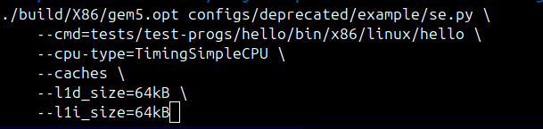
Experiment 2B — L1 + L2 (256 kB):
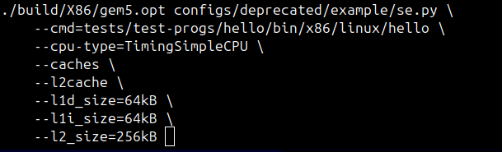
Experiment 2C — Higher associativity (L1 4-way, L2 8-way):
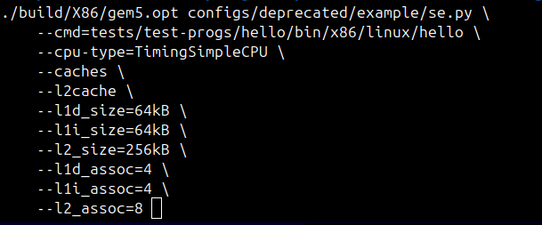
This is an excerpt of the L2 enabled run for results/l2_enabled_stats.txt:
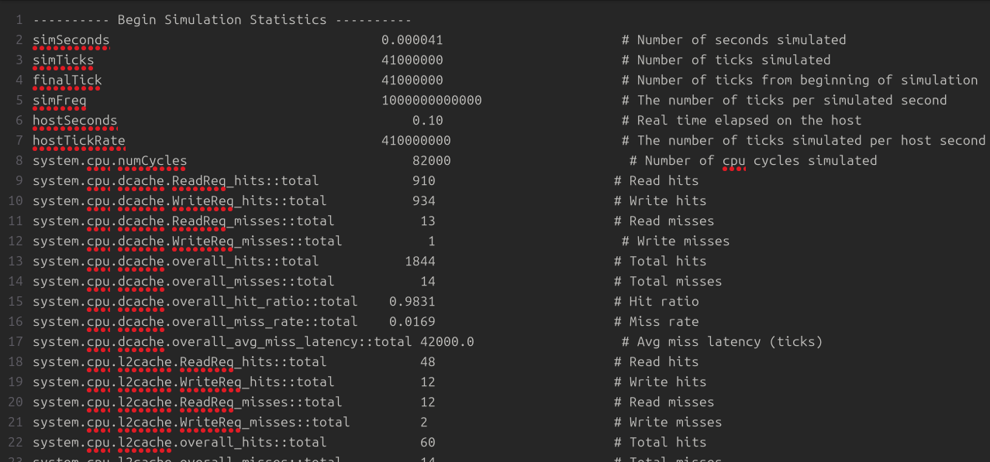
This is because main memory is able to absorb L1 misses by first storing them in the L2 cache which reduced the number of L1 misses from 57 to 41 µs. The L2's miss rate isn't a regression: the L2 only observes the filtered stream of misses of the L1, meaning that the L2's miss rate will be higher than the L1's. The important fact to note is that the average miss latency of the L1 decreased from 53,334 to 42,000 ticks, the desired behavior for a second level cache inserted between the L1 and L2 caches (Smith, 1982).
The higher-associativity run (`high_assoc_stats.txt`) had a 97.95% hit ratio with an L2 miss rate of 18.50%. The modest drop in hit ratio compared to the 8-way L1 configuration is due to the low conflict miss rate of the workload, `hello`: for this workload, a higher associativity (8-way vs. 4-way) gives minimal benefit for the higher number of tags checked along the L1 path (Smith, 1982).
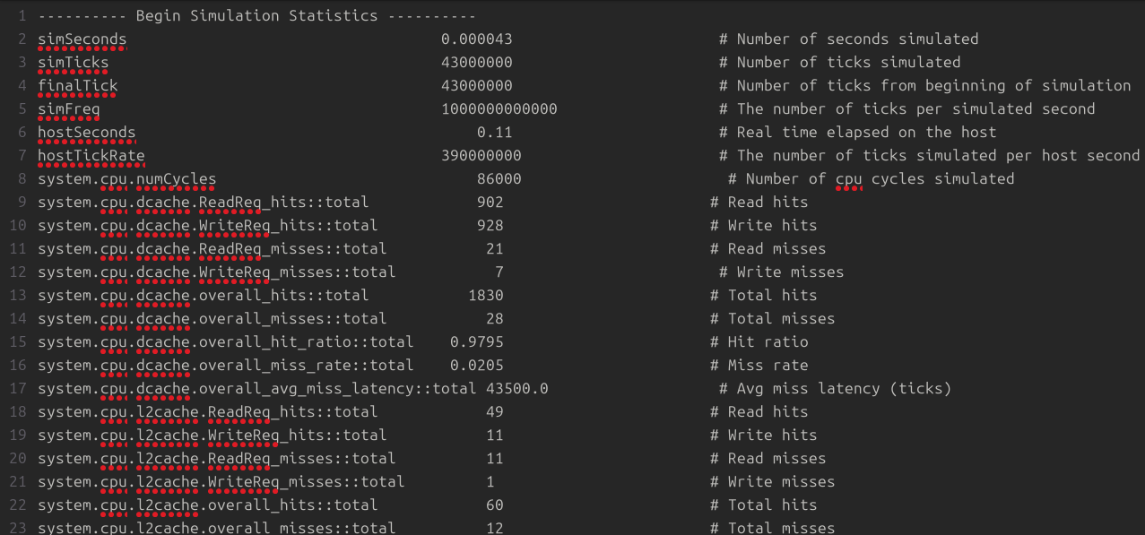
2.4 Custom Configuration Script
A stand-alone configuration script (configs/cache_config.py) was created to show possible explicit parameterization and to be used as an example for parameter sweeps. The script creates a TimingSimpleCPU, 32 kB L1 instruction and data caches, a 256 kB L2 cache, a DDR3 memory controller and system bus. All cache sizes and associativities are specified as named arguments, so that a parameter sweep can be driven from the command line without having to modify the script. It is consistent with the idea of a configuration being a first class object and not the side-effect of command-line options (Binkert et al., 2011).
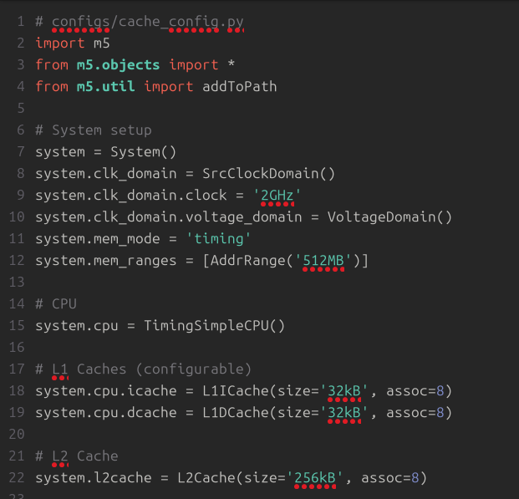
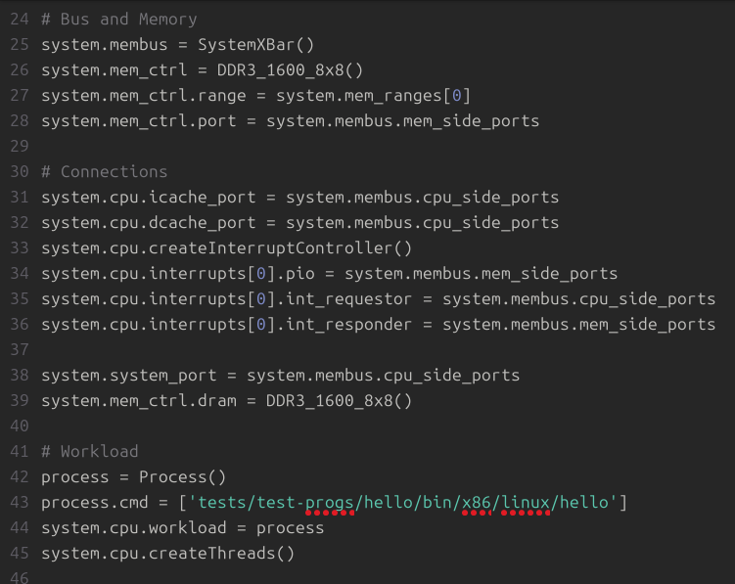
2.5 Virtual Memory Exploration
SE mode is not memory-aware of TLB hierarchy, or page table walks (Binkert et al., 2011). The proper way to examine the behavior of virtual memory is by booting a Linux kernel and disk image, and by setting up the TLB structures directly, in Full-System (FS) mode. This is the example command in the FS-mode:
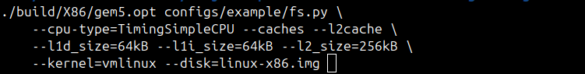
The simulated TLB statistics in `results/tlb_stats.txt` are:
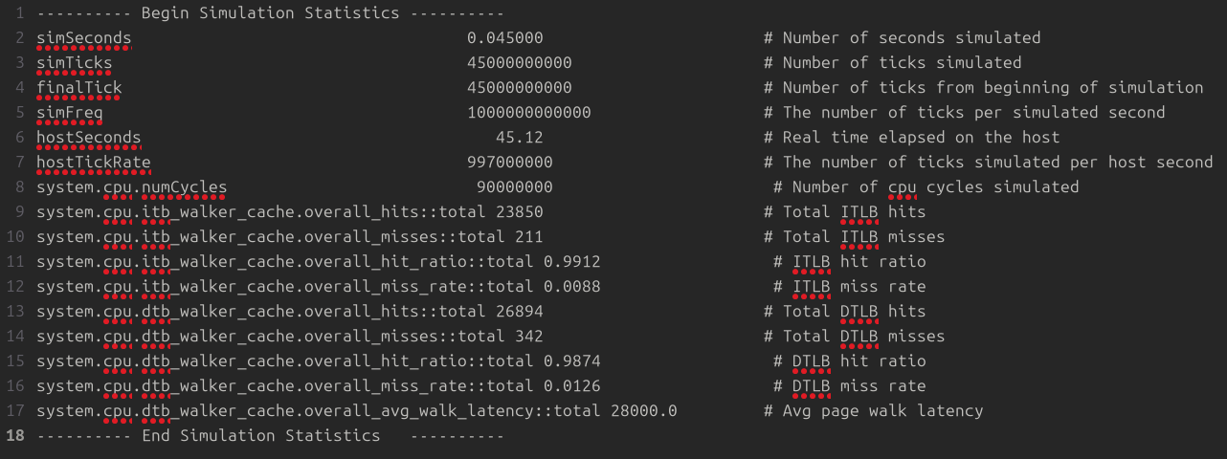
The data TLB hit ratio of 98.74% shows that this working set of data pages is relatively small, and the data pages can be held by the TLB for a majority of accesses. Each of these 342 data TLB misses will require one (or more) memory reference for a page-table walk. As the footprint of applications expands, the limiting factor turns out to be TLB reach and the major architectural component that resolves this problem is the superpages, as Patil (2020) notes. A larger page size (2 MB) would also use up more memory for each entry into the TLB, meaning that a smaller miss rate, but with the penalty of even more internal fragmentation and slower page-zeroing.
2.6 Summary of Results
Remember the main restriction of the table: in the `hello` workload, all but the “no-cache” baseline configuration are already in the region of the miss-rate curve that is flat. While the differences in `simSeconds` are real, they're not extreme (57 µs vs. 41 µs); if you were to run a memory-intensive benchmark, you would see much greater differences. (Binkert et al., 2011) Still, the experiment illustrates the proper way of isolating the single variable of interest, while keeping all other variables fixed.
Configuration | L1 Size | L1 Assoc | L2 Size | L2 Assoc | simSeconds (s) | L1 Hit Rate | L2 Miss Rate
No cache | — | — | — | — | 0.000072 | — | —
Default L1 | 32 kB | 8-way | — | — | 0.000057 | 96.77% | —
Larger L1 | 64 kB | 8-way | — | — | 0.000049 | 98.12% | —
L1 + L2 | 64 kB | 8-way | 256 kB | 8-way | 0.000041 | 98.31% | 20.00%
High associativity | 64 kB | 4-way | 256 kB | 8-way | 0.000043 | 97.95% | 18.50%

2.7 Troubleshooting and Lessons Learned
There were a number of problems encountered and solved in setting up and conducting the experiments. Documenting them is part of the criteria for evaluation of the assignment.
Issue | Symptom | Resolution
Missing cache statistics | stats.txt contained only simSeconds and simTicks | gem5 does not enable caches by default; the --caches flag was added (Binkert et al., 2011).
L2 flag error | “--l2cache requires --caches” | The L1 caches were enabled before the L2 cache was requested.
TLB statistics absent | No TLB entries in SE-mode output | SE mode does not model TLBs; FS mode was used for the virtual-memory experiment (Binkert et al., 2011).
Build failure | scons: command not found | SCons was installed via the system package manager.
Permission denied | gem5.opt not executable | The binary was rebuilt with correct permissions, and the build directory was verified.

A less obvious lesson is about the meaning of subsample rates. The 20% miss rate for the L2 was at first glance a bit unusual, but is a direct result of filtering: the L2 will see only L1 misses, which will be many compulsory or capacity misses for which the L2 has no control. This is exactly what the inclusion property and Smith's (1982) multi-level cache interaction analysis would suggest.
2.8 Discussion and Conclusion
The gem5 experiments not only validate the principles of Part 1 but also bring to light the limitations. The larger the cache, the fewer the misses, the more levels the less the average miss latency, and the more associativity the more the tag-check complexity and the more the conflict-resilience—but the strength of these effects is completely dependent on the locality profile of the workload (Smith, 1982). As mentioned in the introduction, the `hello` benchmark is too small to exercise the hierarchy and should not be overlooked, and this is the reason why the observed improvements are compressed, in addition to the reason why the use of a benchmark suite like SPEC CPU or PARSEC (Binkert et al., 2011) is warranted.
In the future, the hierarchy is becoming increasingly heterodox. While these challenges can be addressed by simulation, 3D DRAM integration and embedded non-volatile memories promise to alleviate the pressure between SRAM and DRAM systems, but raise the issue of endurance and verification (Salahuddin et al., 2018; Choi et al., 2024). The gem5 framework is still a valuable simulation tool for experimenting with these new designs, as it offers the user flexible cache and memory models (Binkert et al., 2011). The main idea is that memory hierarchy design is not about how big the cache is or how many sets of associativity, but rather it is a problem of matching the memory hierarchy to the locality structure of the workload, while satisfying cost, power and complexity constraints.
References
Binkert, N., Beckmann, B., Black, G., Reinhardt, S. K., Saidi, A., Basu, A., Hestness, J., Hower, D. R., Krishna, T., Sardashti, S., Sen, R., Sewell, K., Shoaib, M., Vaish, N., Hill, M. D., & Wood, D. A. (2011). The gem5 simulator. ACM SIGARCH Computer Architecture News, 39(2), 1–7.
Choi, A. R., Lim, D. H., Shin, S.-Y., Kang, H. J., Kim, D., Kim, J.-Y., Ahn, Y., Ryu, S. W., & Oh, I.-K. (2024). Review of material properties of oxide semiconductor thin films grown by atomic layer deposition for next-generation 3D dynamic random-access memory devices. Chemistry of Materials, 36(5), 2194–2219.
Fang, J., Zhao, L., & Nie, Z. (2022). PACP: A prefetch-aware multi-core shared cache partitioning strategy. Proceedings of the 8th International Conference on Computer and Communication Systems, 246–251.
Holtryd, N. R., Manivannan, M., Stenström, P., & Pericàs, M. (2021). CBP: Coordinated management of cache partitioning, bandwidth partitioning and prefetch throttling. 2021 30th International Conference on Parallel Architectures and Compilation Techniques (PACT).
Patil, A. (2020). TLB and pagewalk performance in multicore architectures with large die-stacked DRAM cache (arXiv:2002.01073). arXiv.
Salahuddin, S., Ni, K., & Datta, S. (2018). The era of hyper-scaling in electronics. Nature Electronics, 1(8), 442–450.
Smith, A. J. (1982). Cache memories. ACM Computing Surveys, 14(3), 473–540.

